# A brief summary of my activities, contributions and artifacts I have produced during the past week

In the previous week we discussed to implement the inventory module with some more functionalities. And project mates discussed to implement something “cool” to fulfil that module. At the end of the discussion we finalize that we will implement the same thing which is currently happen in GMAIL app that is “Customize Swipe Action” on the contents. And again the task came in to my pot. At that time I did not know that how I can achieve that and what time it will take to implement it and is it possible to integrate it with Jarvis and all that but somehow I said “YES”. And at the time of implementation I was literary poor. There were no clues, no sources and no tutorials to implement what we finalized. So it took my 3-4 days and after that I came up with very cool and fabulous (I can say that) view. So, these are my efforts and my contributions to the Jarvis for the last week.

Apart from this, as I presented my last work i.e. Reminder App using Material Platform, I could not able to integrate it into the Jarvis. At the time of writing this blog the situations are same. There is no integration of App Reminder to Jarvis. I talked to my team mates and none of them were ready to help me. I discussed these with Clayton (my sub team mate for Prevention/Maintenance), he told me that he has no experience with Android and Android Studio and I was like OMG (then why are you here?). So I decided to integrate it by myself. So I completed that Inventory module by Sunday so that I can spend two days for integration.

1. Added Reminder module to the Navigation Drawer

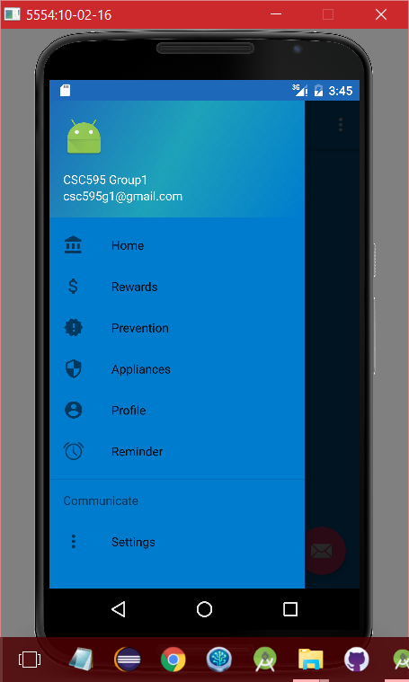

1. Added Inventory module to the Navigation Drawer



1. Home Screen for Inventory Module

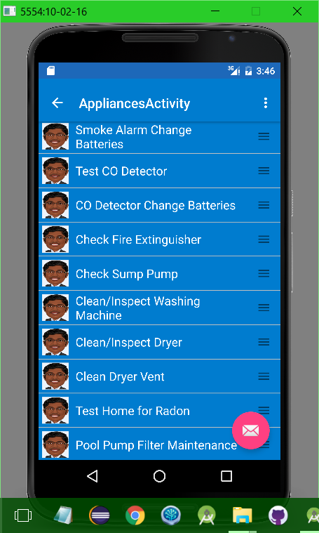

1. List of possible Appliances into the Application

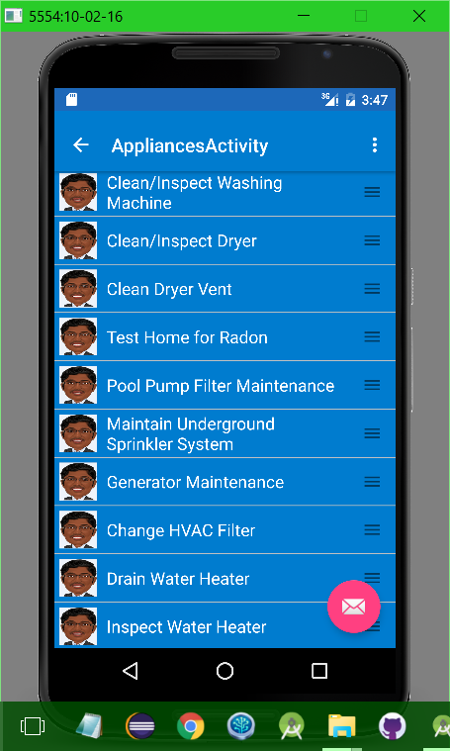

1. onClick() function

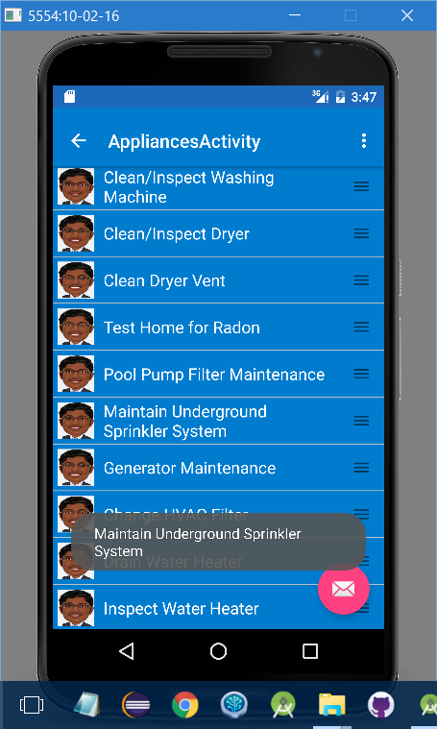

1. Delete function

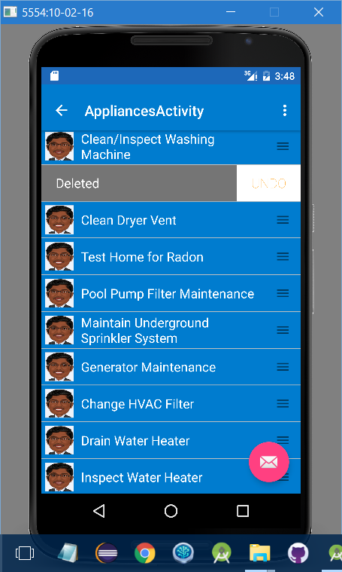

1. Swipe function

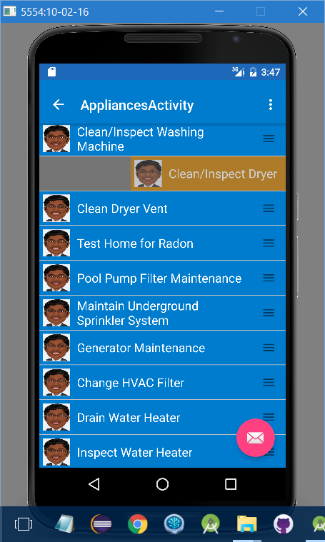

1. Undo function

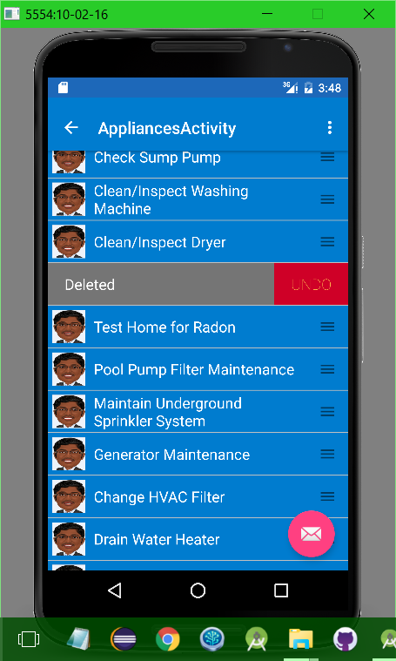

1. Drag and Drop function

As you can see that the very first element is “Smoke Alarm Change Batteries” and User can change the order of elements by using Drag N Drop function.

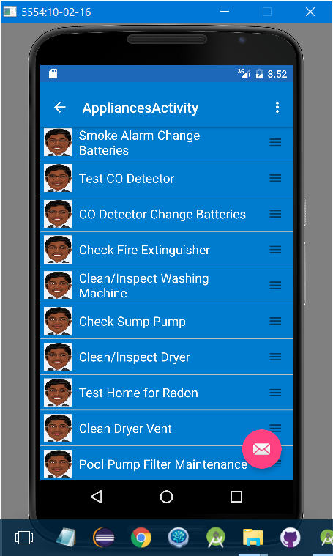

Now after Drag and Drop. “Smoke Alarm Change Batteries” goes to 3rd place and CO Detector will replace with the 1st place.

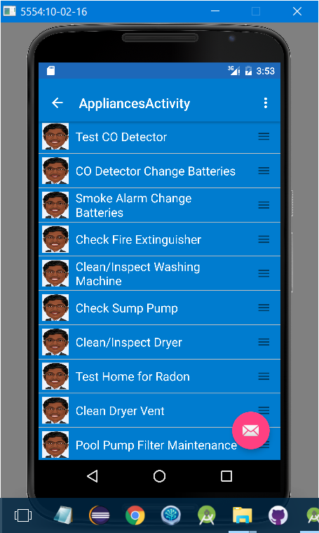

# My plans, thoughts and reflections on the state of the project for the next week

As I already mentioned that the integration of Reminder App is still a tough task for everyone. And I will take initiative to integrate it to the Jarvis. I need more couple of nights to finish it. So my very first and important task for the upcoming week is to integrate Reminder and add some more functions as you suggest me in our previous meeting.

Moreover, I’m working on the Trello Board. I’m planning to use the functionalities of Trello board in to user profile to make some more real life feelings. I think this is too early to explain you about this but I’m working over it. By next week, I’m planning to complete most of the task and properties required from Prevention/Maintenance. Let us see what other things will come in to the next project meeting.